Analyzing Food Access on Campus and Sustainability to inform action on how the University of Utah Campus can continue to enforce sustainability
Isabella Lopes
Objective: To examine and review the steps the University of Utah has taken to enforce food sustainability on campus along with organizations that have aided in analyzing food access and sustainability on campus.
Methods: I conducted interviews with the Food Recovery Network with who I also volunteered with in the Heritage Center. I also had the opportunity to interview Jennifer Nielsen, who is in charge of Chartwell Dining Services on campus and the Founder and President of Waste Less Solutions, Dana Williamson. There was also research done on different forms of sustainability on campus such as the campus gardens, composting, and participation in the biodigester.
Results: Participation in the interviews lead to show a good effort the university has made to enforce food sustainability on campus. The Food Recovery Network is a student-run partnership with Chartwell dining in the University of Utah’s dining services. The Food Recovery Network (FRN) has taken left over and untouched food from the Heritage Center and the Union to pack and deliver to those in need. Some of the organizations that receive these foods are homeless shelters, food pantries, and the YWCA. In the spring of 2019, 4000 lbs of food was donated and composting has increased significantly on campus. Chartwell Dining Services has also offered education training on food waste and recovery, giving 12% back to the university and offering scholarships to students. When interviewing Dana Williamson, she spoke on the mission of Waste Less Solutions, which is a non-profit organization that strives to educate, prevent and divert food waste (figure 1). With it’s association with the University of Utah, Waste Less solutions receives food donations from campus which has reduced food waste on campus and help those who face food insecurity in Salt Lake. A recording in November of 2019 estimated that 190,700 lbs of food was saved with only 1% of food organizations signed up to donate in Salt Lake City. Students on campus have also taken a part in food sustainability by participating in the farmers markets, using the campus gardens and composting. The University of Utah has also given food to the anaerobic biodigester in Salt Lake which composts all types of food including fruits, vegetables, meat products, breads, and so on and turns it into clean energy (figure 2). The University is currently building a biodigester on campus that is estimated to be opened in august of 2020.
Conclusion: The University of Utah has taken a stance to ensure and promote food sustainability on campus but there is more that can be done. Students have expressed that a reduction in the use of plastic on campus would be most helpful in continuing the progression of reducing waste on campus and helping reduce food that is packed in plastic. With only the Heritage Center and the Union participating in food donations, there are other restaurants and dining services on campus that could participate in food donations and work with the Food Recovery Network on campus as well as Waste Less Solutions. Having volunteered with the FRN, there are a limited amount of students who know about this group and it would be beneficial for students to become aware of ways to eat sustainably and to help reduce food insecurity within their community.

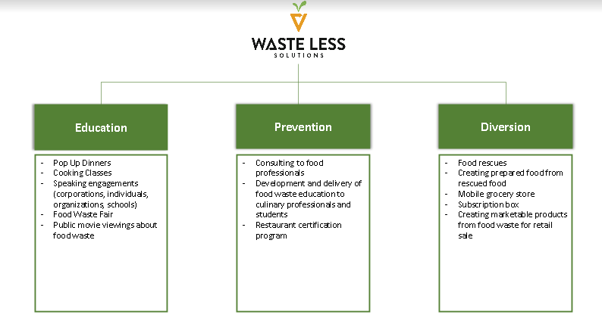
Figure 1: Wasteless Solutions, 2019.

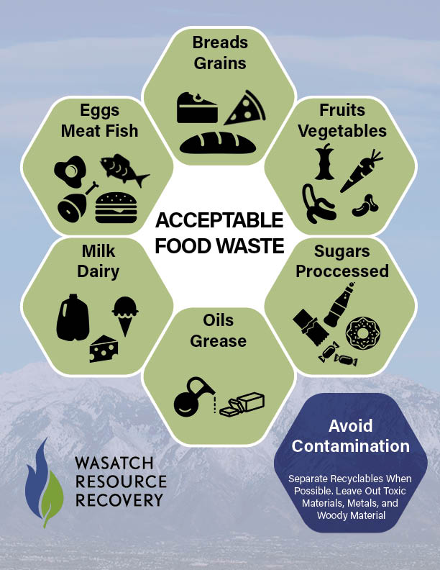
Figure 2: Wasatch Resource Recovery, 2018.

