Thomomys size change in relation to El Niño variation from the site Abrigo De Los Escorpiones in Baja, California
GinnyRyan Andersen

Abstract:
El Nino is one part of the ENSO cycle, it is a major global climatic phenomenon. It brings more moist and warmer sea surface conditions. This affects the terrestrial life when El Nino is frequent. There is little of a long-term record of Thomomys size variation in correlation to El Nino frequencies. Here we examine the size variation in correlation of frequencies and the results were not expected but could help with conservation and modern management as well as further research to contribute to the littatures done on these studies.
Objective:
El Nino is a global environmental climate phenomenon, which brings warmer and moist conditions to North America (figure 1). The wetter conditions of El Nino contribute to more plentiful vegetation and better conditions for terrestrial life. There is not much information on how El Nino frequencies impact small mammals and rodents over long periods of time.
The site Abrigo de los Escorpiones in Baja California is featured on the coast of Mexico south of California (figure 2 and 3). It consists of a rock shelter near the coast in a drier, sagebrush environment. This site can help address the issue because it has a large and wide range of faunal assemblage that dates to 12,000 years. Isaac Hart (2015) worked on this site, studying how El Nino frequencies affect lagomorph (rabbits and hares) diversity. He concluded that it does have a correlation, where periods with frequent El Nino events have had more abundance of mesic lagomorphs, who prefer cooler and moist climates. I plan to contribute to this study by studying Thomomys size in relation to El Nino frequencies.
I hypothesize that Thomomy size will grow in El Nino years due to the improved amount of vegetation. I will select several elements and establish dimensions on them to measure (mandible tooth row and diastema length) and measure all the selected elements from the best dated unit (D4) from Escorpiones (figure 4). I will then evaluate the correlation between gopher size and the frequency of El Nino events (per century) for the entire assemblage that spans the last ~12,000 years. If this proves significant it indicates that the change in climatic environment will impact Thomomys lifestyle and how we can help them in future climatic changes.
Methods and Materials:
I used the University of Utah’s comparative collection to compare thomomys skeletons to the fossil remains found in unit D4 from the site Abrigio De Los Escorpiones (figure 4). After isolating and identifying mandibles as thomomys, I measured the mandible diastema featured in figure (5) and the mandible tooth row featured in figure (6). I started in 0-5 centimeter increments from there, 10-20 centimeter increments and moved up in 10 centimeters up until 500 centimeters. I had a total NSIP of 504 mandibles measured. I then used Spearman’s Rho to calculate my results.
Results:
My results came back and showed a negative correlation between El Nino frequencies and pocket gopher size. In figure (7) it showed the relationship between mandibular tooth row measurements and El Niño frequency (rs=-.603, p= .001), where size of pocket gophers is more diverse when El Nino frequencies are low and then less size diversity when frequencies are high. This correlation is the same for the relationship between mandibular diastema measurements and El Niño frequency (rs=-.506, p= .001) shown in figure (8). In figure (9) you can see that sizes in pocket gophers over the last 12,000 years BP decreases significantly when El Nino frequencies are rising and are increasingly higher when the frequencies are happening less often.

Conclusions and Discussions:
My hypothesis was rejected; this could be the result of age variation through time in relation to El Niño. Higher El Niño frequency could drive gopher population increases that would be associated with higher proportions of young animals. Instead of using the measurements from the mandibles, the measurements of long bones could be used instead of mandibles to look at fused epiphyses to control for age variation.
This research helps contribute to modern management and conservation. Gophers of course are a primary prey item for a wide range of carnivore and avian predators. The more we know about how rodent populations respond to El Niño on long term time scales, the better off we’ll be at managing rodent populations today and into the future
Acknowledgments
I’d like to thank Jack Broughton, Isaac Hart, for your teachings, help, and running an awesome field school. Kasey Cole and Miranda LaZar, for all their help and support. As well as my fellow students from the Zooarchaeology and Ecology field school for support and laughter. As well as the Lassen County Youth Camp owners for a place and supplies for us to stay and conduct research and learning.
References
Hart, Broughton, & Gruhn. (2015). El Niño controls Holocene rabbit and hare populations in Baja California. Quaternary Research, 84: 46-56.

Figure captions
Figure 1: El Nino frequencies demonstration
Figure 2: Escorpiones location on a map
Figure 3: Panorama of Escorpiones
Figure 4: Escorpiones stratification levels
Figure 5: Mandibular diastema measurement
Figure 6: Tooth row measurement
Figure 7: : Relationship between mandibular tooth row measurements and El Niño frequency (rs=-.603, p= .001)
Figure 8: Relationship between mandibular diastema measurements and El Niño frequency (rs=-.506, p= .001)
Figure 9: Relationship between mandibular tooth row and mandibular diastema measurements and El Niño frequency

Figures

Figure 1:
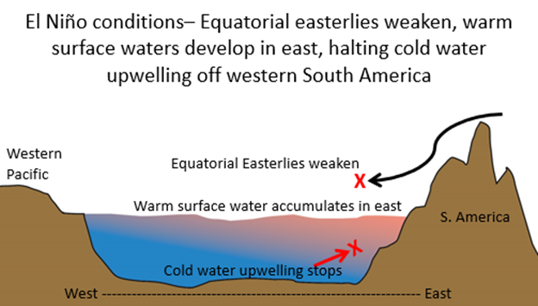
Figure 2
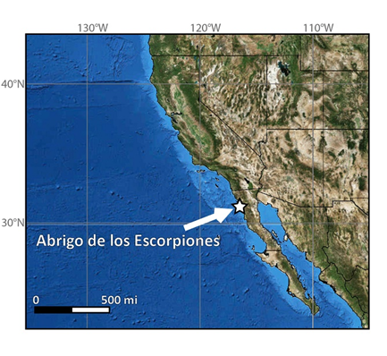

Figure 3

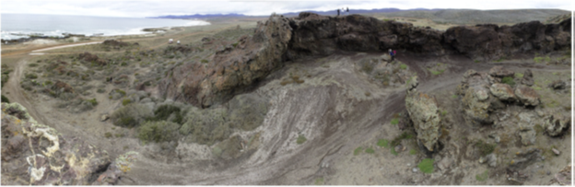

Figure 4

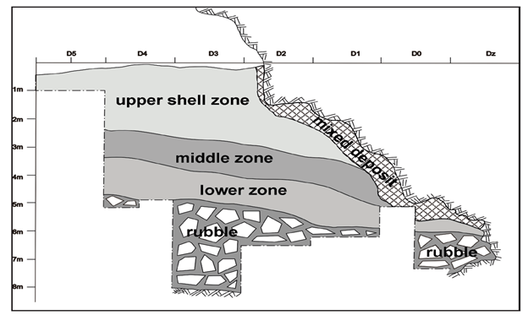

Figure 5

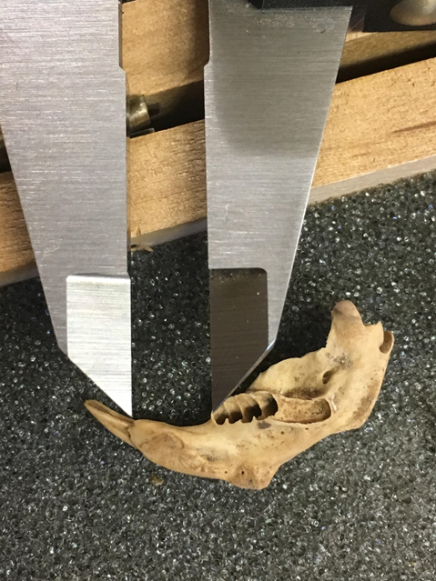

Figure 6
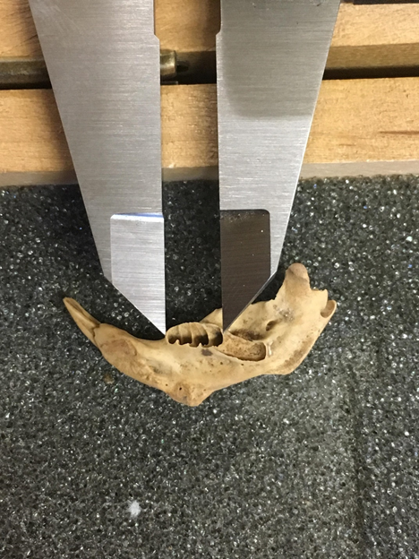

Figure 7
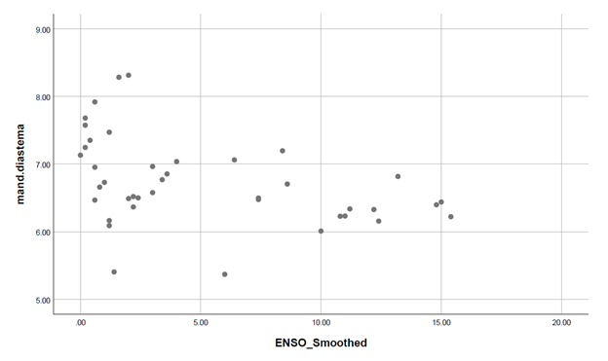
Figure 8

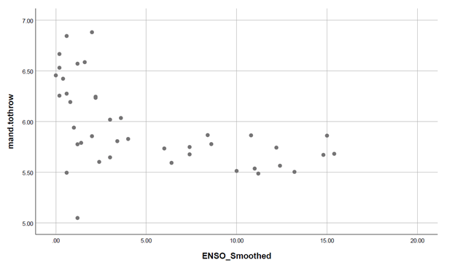

Figure 9
